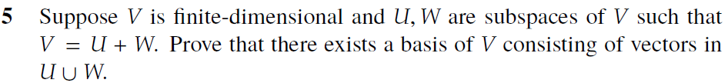

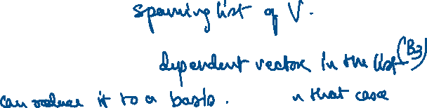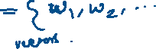

<https://math.stackexchange.com/questions/4919826/is-finite-dimensional-are-subspaces-of-prov>

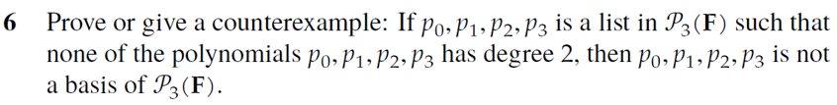

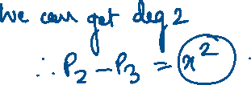

<https://math.stackexchange.com/questions/1810250/prove-or-disprove-there-exists-a-basis-p-0-p-1-p-2-p-3-in-p-3f-such-tha>

